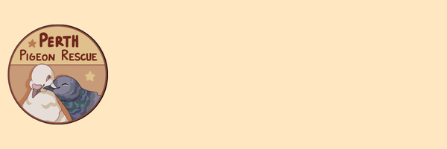
PPR Adoption Application
PPR Adoption Policy
PPR shopping guide

Before You Apply*
- By checking this box, you have read and agree to follow our adoption policy outlining our standard of care and living requirements to ensure the safety and wellbeing of our bird(s).

Date of Birth (If the applicant is under 18, a parent/guardian must complete this form. Please list the applicants age below).*
Contact details.
First and Last name:
Email:
Phone:
Address:
General Information
Please tell us why you would like to adopt a pigeon(s)?
Do you own your own home or have permission from your landlord to keep a pigeon(s)?*
- Own.
- Renting with permission.
- Other:
Are you prepared to provide a safe, permanent home for their full lifespan of 10-15+ years?*
- Yes
- No
- Other:
Are you committed to providing a permanent home for them, even if the behaviour or personality is not what you expect? *
- Yes
- No
- Other:
Have you owned birds previously or have experience with birds? If so what species?*

How much time could you dedicate to spending with the bird(s)?*

Does anyone in your household smoke? *
- No.
- Yes, but can provide a smoke-free area. If not, please explain.
- Other:

What area will the bird(s) be spending most of their time? Please detail. *
Please provide a photo of the area they will be living in. Or send your photos via our email address perthpigeonrescue@gmail.com or Facebook Messenger.
What cage/aviary do you have, or are planning to get? Please provide details and dimensions. *
Please provide a photo of the cage/aviary you have set up or are purchasing. Or send your photos via our email address perthpigeonrescue@gmail.com or Facebook Messenger.

Will the pigeon(s) be sharing with other pigeons or birds? If so, what species, type, age and sex?*
Do you plan on allowing the bird(s) to free fly outside? *
- Yes.
- No.
- Other:
Unless for medical reasons, do you agree to not clip your birds' wings?*
- Yes.
- No.
There are so many pigeons that need a home, do you agree to prevent your pigeon(s) from breeding? (e.g. swapping fertile eggs for fake eggs).*
- Yes.
- No.
- Other:
In times of illness or injury are you able to take them to a qualified avian vet at your own expense?*
- Yes
- No
- Other:

We understand that circumstances can change. The adopter agrees that if they are no longer able or willing to care/keep the pigeon for any reason, the bird will be returned to Perth Pigeon Rescue.*
- Yes
- No

Have you been convicted of animal cruelty? *
- Yes
- No

Is there a specific pigeon you are interested in, or anything you are looking for in an adopted pigeon(s)?

Do you understand and accept that by adopting a pigeon, you assume full responsibility for its care, and that Perth Pigeon Rescue (PPR) is not liable for any injury or illness to you or the pigeon following adoption?

Please fill this form out and return it to perthpigeonrescue@gmail.com with your enclosure photos.

