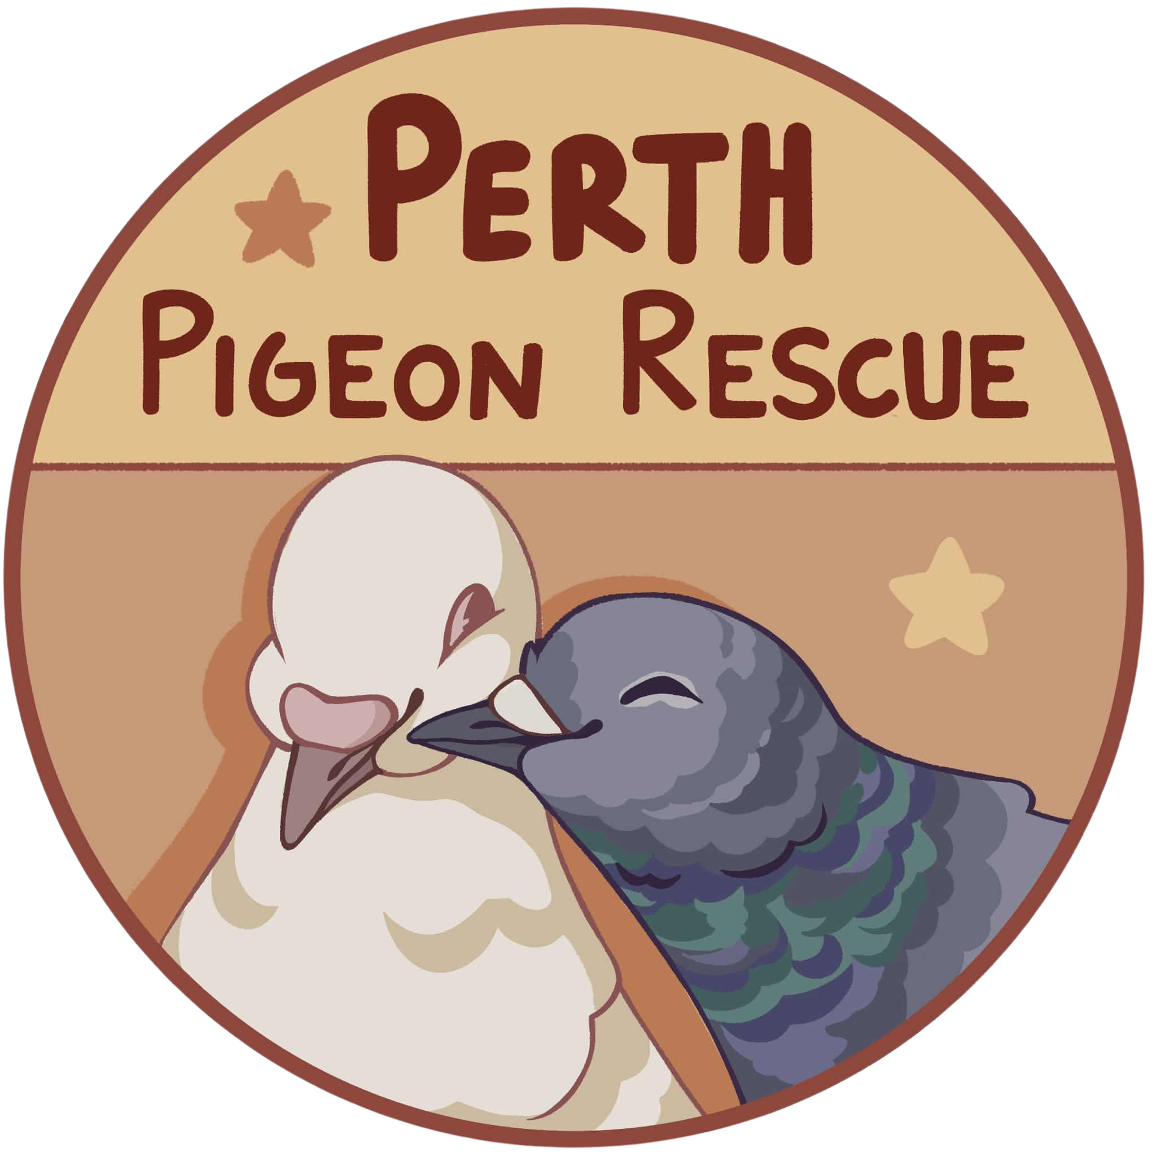
Perth Pigeon Rescue Foster Policy
Please take time to reflect on these questions before applying:
- Can you provide secure housing that protects against predators and weather?
- Are you financially prepared for everyday costs?
- Do you have landlord approval for fostering pigeons?
- How will a foster pigeon fit into your household with other pets or family members?
We ask these questions to help ensure that fostering is the right choice for both you and the bird.

What We Require
Housing
A pigeon-appropriate cage or aviary must be set up before adoption. Housing must be safe, secure, and large enough for natural behaviours such as flying, perching, and bathing. Enclosures must be kept clean and sanitary, with waste removed regularly and adequate ventilation. Please check out our pigeon product supply list for more information on what is required.
No Breeding, Racing, or Meat Use
So many pigeons are already in need of homes, we ask foster carers to agree to prevent breeding (for example, by replacing fertile eggs with fake eggs). We can provide you with fake eggs if needed, or you can make your own from clay or order online.
Age Requirement
Applicants must be at least 18 years old to foster. Young people are welcome to help care for the bird, but a parent or guardian must complete the adoption process and hold legal responsibility.
Commitment to Care
By fostering through Perth Pigeon Rescue, you agree to provide care, contact us immediately if the pigeon requires veterinary attention, and return the bird to us if you are ever unable to provide for them. We do not allow the rehoming of pigeons without our approval.
Free Flying
For their protection, pigeons and doves from Perth Pigeon Rescue must not be free-flown outdoors. Free flying is unsafe due to the high risk of hawk attacks, getting lost or injured.
Please do not free-fly your birds, but provide them with a large aviary, let them inside the house for flight time or in a safe enclosed space.
Adoption material
You will be asked to take photos or videos of your foster pigeon(s) from time to time. This is to help promote and advertise them on our website and Facebook page. Monitoring their behaviour and personality is also important to let us know what they are like as a pigeon, making it easier to find a suitable home.

Pigeon Adoption
You might be asked to contact a potential adopter about a bird to drop off or organise a pick up. If you are not comfortable with this, please pass the bird on to us prior to adoption. Foster carers must not rehome the bird themselves without PPR approval.

Time limit
Adoption wait times are unknown. If you can only look after a pigeon for a certain period of time, let us know as soon as possible.
Questions? Contact us at perthpigeonrescue@gmail.com.
Signature _________________________________________________________________
Date ___/ ___ /_______

