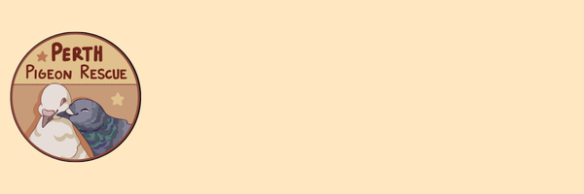
Adoption Policy
Adopting a pigeon or dove is a long-term responsibility. These birds can live 10–15 years or more, and they depend on you for safety, companionship, and care throughout their lives. Please take time to reflect:
- Can you provide secure housing that protects against predators and weather?
- Are you financially prepared for both everyday costs and veterinary emergencies?
- Will your current and future housing allow you to keep birds?
- How will a pigeon fit into your household with other pets or family members?
We ask these questions to help ensure that adoption is the right choice for both you and the bird.

What We Require
Housing
A pigeon-appropriate cage or aviary must be set up before adoption. Housing must be safe, secure, and large enough for natural behaviours such as flying, perching, and bathing. Enclosures must be kept clean and sanitary, with waste removed regularly and adequate ventilation. Please check out our pigeon product supply list: Link
No Breeding, Racing, or Meat Use
Because so many pigeons are already in need of homes, we ask adopters to agree to prevent breeding (for example, by replacing fertile eggs with fake eggs). We also do not adopt to anyone intending to race or use pigeons for meat.
Age Requirement
Applicants must be at least 18 years old to adopt. Young people are welcome to help care for the bird, but a parent or guardian must complete the adoption process and hold legal responsibility.

Commitment to Care
By adopting through Perth Pigeon Rescue, you agree to provide lifelong care, seek veterinary attention when needed, and return the bird to us if you are ever unable to provide for them. We do not allow the selling or rehoming of our birds without our permission and approval.

Free Flying
For their protection, pigeons and doves adopted from Perth Pigeon Rescue must not be free-flown outdoors. Free flying is unsafe due to the high risk of hawk attacks, getting lost or injured. Please do not free-fly your birds, but provide them with a large aviary, let them inside the house for flight time or in a safe enclosed space.

Adoption is not just about giving a bird a home, it is about offering safety, dignity, and respect for the rest of their life.
Questions? Contact us at perthpigeonrescue@gmail.com.

