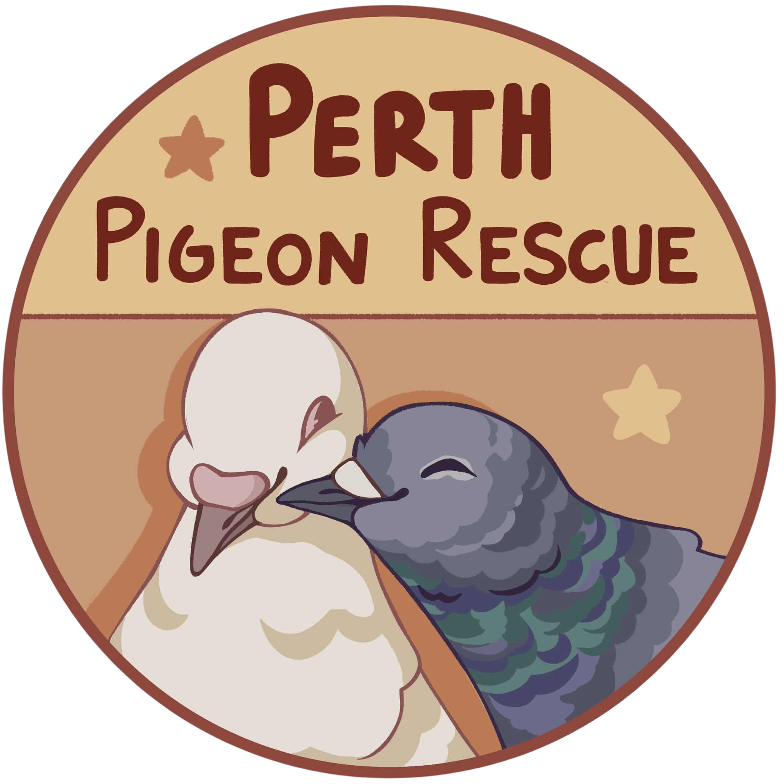
PERTH PIGEON RESCUE
ADOPTION CONTRACT

Name of Adopter:_____________________________________________________________
Name/s of Pigeon/s or Dove/s Being Adopted:_____________________________________

Terms of This Agreement
By signing this agreement, you agree to provide a safe, appropriate and permanent home for the pigeon(s) or dove(s) you are adopting from Perth Pigeon Rescue and to comply with the following conditions.

1. Safe & Appropriate Housing
A pigeon-appropriate cage, indoor setup or aviary must be provided. Housing must be safe, secure and large enough for natural behaviours such as flying, perching and bathing.
Housing must provide protection from predators and weather and be kept clean, sanitary and adequately ventilated.
Adopter Initials: __________

2. No Free Flying or Release
Pigeons and doves adopted from Perth Pigeon Rescue must not be released or allowed to free-fly outdoors.
Free flying carries the risk of predator attacks, becoming lost or being injured.
Birds can instead be provided with flight time indoors or in a safe, fully enclosed outdoor space such as a secure aviary.
Adopter Initials: __________

3. No Breeding
There are already more pigeons in need of homes than there are suitable homes available. Pigeons and doves adopted from Perth Pigeon Rescue must not be intentionally bred.
Where there is a possibility of fertile eggs, adopters are responsible for preventing breeding, including replacing fertile eggs with fake eggs where appropriate.
Adopter Initials: __________

4. Companion Animals Only
Pigeons and doves adopted from Perth Pigeon Rescue are adopted as companion animals.
They must not be used for racing, breeding, meat, training other animals, resale, deliberate release or any other purpose that may unnecessarily place their welfare at risk.
Adopter Initials: __________
5. Ongoing Care & Veterinary Treatment
By adopting through Perth Pigeon Rescue, you agree to provide lifelong care, appropriate food and clean water, safe housing, companionship and enrichment, and veterinary attention when needed.
Once adopted, you are responsible for the ongoing costs associated with caring for your adopted bird, including veterinary treatment that may be required for previously unknown health conditions.
Adopter Initials: __________

6. Return to Perth Pigeon Rescue
If at any time you are no longer willing or able to care for a pigeon or dove adopted from Perth Pigeon Rescue, the bird must be returned to Perth Pigeon Rescue.
You must contact Perth Pigeon Rescue as soon as possible so arrangements can be made for the bird to return to our care.

Adopted birds must not be sold, given away, rehomed, surrendered or transferred to another person, rescue or organisation.
Under no circumstances may an adopted bird be abandoned or released.
Adopter Initials: __________

7. Follow-Up
Perth Pigeon Rescue may contact you following adoption to check how your adopted bird(s) are settling into their new home.
If we have reasonable concerns about the welfare of an adopted bird or whether the conditions of this agreement are being followed, we may ask for updates, photographs or information about the bird and their housing.
Adopter Initials: __________

8. Keep Us Updated
We love hearing how our adopted pigeons and doves are going. While regular updates aren’t compulsory, we welcome photos, videos and stories about your adopted bird(s).
With your permission, we may share suitable updates with the Perth Pigeon Rescue community, including on our social media pages.

Adopter Agreement
I, _______________________________________________________, confirm that I have read and understood the terms of this Adoption Agreement.
I agree to provide appropriate lifelong care for the pigeon(s) or dove(s) I am adopting and agree to comply with the conditions outlined above.
I understand that:
- My adopted bird(s) must not be free-flown or released outdoors.
- My adopted bird(s) must not be intentionally bred.
- If I can no longer care for my adopted bird(s), they must be returned to Perth Pigeon Rescue.
- I must not sell, give away, rehome, surrender or transfer my adopted bird(s) to anyone else.

Signatures
Adopter Name: ______________________________________________________________________
Signature: ______________________________________Date: _______________________________

Perth Pigeon Rescue Representative: Signature: _________________________Date: ____________

